# Lab: Arrays and Matrices

Problems for in-lab class for ["JavaScript Fundamentals Course@SoftUni".](https://softuni.bg/trainings/2247/js-fundamentals-january-2019) Submit your solutions in the SoftUni judge system at<https://judge.softuni.bg/Contests/Practice/Index/1464>.

## Sum First Last

Write a JS function that calculates the multiplication of each element with the length of an array. Then print each index of the array with his value as follows:

**{index} -> {element}**

The **input** comes **as an array of string elements** holding numbers.

The **output** must be rendered in a newly created paragraph element **p for each row.**

### Examples

|  |  |
| --- | --- |
| **Input** | **Output** |
| ["1", "2", "3", "4", "5", "6"]; | 0 -> 6  1 -> 12  2 -> 18  3 -> 24  4 -> 30  5 -> 36 |

### Hints

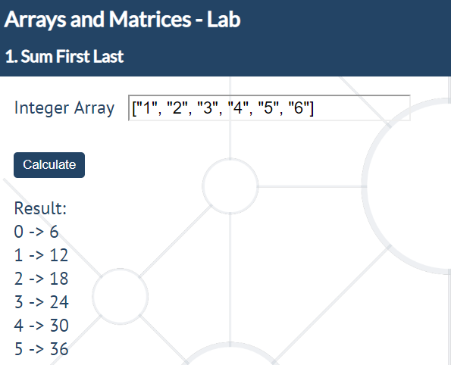

## Even Position Element

Write a JS function that finds the elements at even positions in an array.

The **input** comes as an **array of number** elements.

The **output** must be displayed into element with **id result** like a **text/string**.

|  |  |
| --- | --- |
| **Input** | **Output** |
| [1, 2, 3, 4, 5, 6, 7, 8, 9] | 1 x 3 x 5 x 7 x 9 |

### Hints

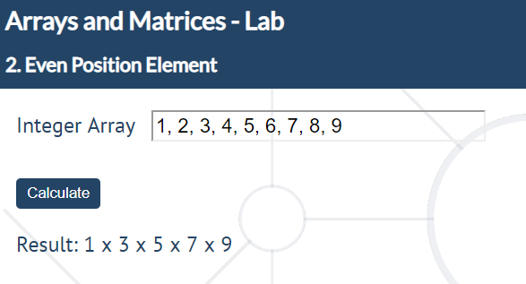

## Replace and Reverse

Write a JS function that receives an array of strings, **reverses the string and make the** **first letter** of each element **upper-case**.

The **input** comes as an **array of strings**.

The **output** must be the resulting array **elements, separated by a space** into element with **id** “**result**” like **text/string.**

### Examples

|  |  |
| --- | --- |
| **Input** | **Output** |
| ["inutfos", "tneduts", "tpircsavaj", "9102", "yraunaj"] | Softuni Student Javascript 2019 January |

### Hints

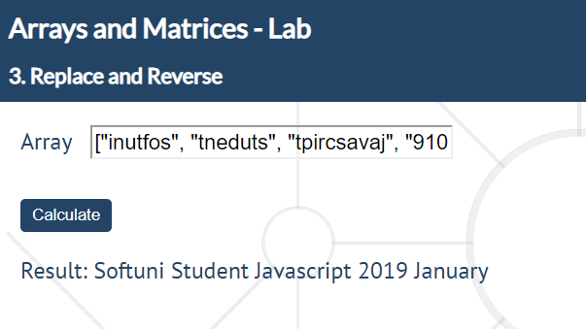

## Find element

Write a JS function that searches an element in a string. If the array has the element, print **"true"** and the **index** of the element. Otherwise, print "**false"** and **-1**.

The **input** comes as two parameters. The first one is the searched element; the second one is an **array of strings** that need to be processed.

The **output** must be displayed in the browser separated by a space into element with id ‘**result**’ like **text/string.**

**{element} -> {index}**

|  |  |
| --- | --- |
| **Input** | **Output** |
| "4", ["1, 2, 4", "one4all", "123567", ["4", "6", "44"]] | true -> 6, true -> 3, false -> -1, true -> 0 |

### Hints

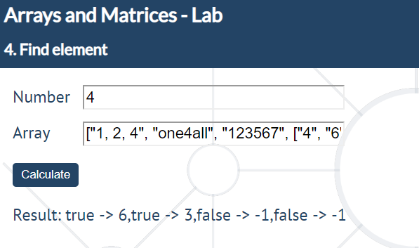

## Multiple sort

Write a JS function that sorts elements of an array, first by ascending order, then alphabetically.

The **input** comes as **array of strings**.

The **output** is two sorted arrays, each in a separate **<div>**'s.

|  |  |
| --- | --- |
| **Input** | **Output** |
| ["4", "5", "46", "71", "8", "9048", "1", "332", "3", "-15","15", "-39"] | [ "-39", "-15", "1", "3", "4", "5", "8", "15", "46", "71", "332", "9048" ]  [ "-15", "-39", "1", "15", "3", "332", "4", "46", "5", "71", "8", "9048" ] |

### Hints

